ĐẠI HỌC QUỐC GIA THÀNH PHỐ HỒ CHÍ MINH

ĐẠI HỌC CÔNG NGHỆ THÔNG TIN

KHOA HỆ THỐNG THÔNG TIN – CHƯƠNG TRÌNH TIÊN TIẾN

ĐỒ ÁN MÔN HỌC

NHẬP MÔN CÔNG NGHỆ PHẦN MỀM

Đề tài: Quản Lý Cửa Hàng Bán Mỹ Phẩm

Nhóm 7

Đặng Trúc Lam 19521736

Lê Ngọc Thúy An 19521176

Võ Quốc Bình 19520417

Tăng Quốc Hưng 19521583

Thành Phố Hồ Chí Minh, 6 tháng 12 năm 2021

Contents

I. ABSTRACT 6

II. OUR PROBLEM: 7

2.1 Processing payment procedures: 7

2.2 Efficient product management 7

2.3 Customer care 7

2.4 Revenue inventory: 7

2.5 Employee manager: 7

III. WORK PROCESS 8

3.1 Define software requirements: 8

3.2 Database Design 8

3.3 Design the theme 8

3.4 Software Testing 8

3.5 Software delivery 8

IV. USE CASE 8

4.1 Actor list 8

4.2 Use case diagram 9

4.2.1 Customer use case 9

V. Analyze 16

5.1. Database Diagram 16

5.1.1. List of class object 16

5.1.2. List of Relationship 16

5.1.3. Class Description 17

5.1.3.6. Order Items 18

VI. UI/UX Design 47

6.1. List of pages: 47

6.2. Details: 48

6.2.1. Welcome Page: 48

6.2.2. About Us: 49

6.2.3. Contact 50

6.2.4. Sign Up 51

6.2.5. Log In: 52

6.2.6. Shop Main Page: 53

53](#_Toc89667270)

VII. Conclusion: 54

￼

7.1.1. Pros: 54

# I. ABSTRACT

Nowadays, the demand for beauty products is increasing day by day. Both men and women are interested in beauty. Therefore, the cosmetic business market becomes more exciting than ever. In order to have a large customer base, cosmetic stores must expand their exposure to customers. And the only way is to do business online. Cosmetic stores need a website to easily reach potential customers. Through the website, customers can buy goods online without being separated by geographical distance. With the website, the store can easily take care of customers and save operating costs such as premises, employees, etc., at the same time, improving competitiveness in the market. During the pandemic, online businesses seem to have become the backbone of business. Building a website is extremely necessary in the present time and in the future.

# II. OUR PROBLEM:

## 2.1 Processing payment procedures:

-Payment procedures at the store are often done manually, which is easy to make mistakes

-Need to switch to input for main calculation

## 2.2 Efficient product management

-Traditional testing methods are time consuming and inaccurate

-Need to transfer information to the database for storage, from which information can be easily retrieved and given appropriate business direction

## 2.3 Customer care

The traditional method has many shortcomings in connecting and taking care of customers

-Need to store customer information, conduct periodic care via mail, chat...

## 2.4 Revenue inventory:

-Difficulty in taking inventory of sales

-The software stores order data and conducts revenue summary.

## 2.5 Employee manager:

-Traditional method cannot track and calculate employee salary accurately

-The software stores employee information and calculates wages based on the number of working days

# III. WORK PROCESS

## 3.1 Define software requirements:

-Listen and analyze requirements from customers

-Survey your opponent

## 3.2 Database Design

-Select database technology

- Relationship modeling

## 3.3 Design the theme

-Implement ideas

-Add, edit, delete functions

## 3.4 Software Testing

-Test programmer

-User testing

## 3.5 Software delivery

# IV. USE CASE

## 4.1 Actor list

|  |  |  |
| --- | --- | --- |
| N.o | Actor name | Note |
| 1 | Customer | Purchase view product |
| 2 | Employee | Manage product, customer |
| 3 | Manager | Manage employee |

## 4.2 Use case diagram

### 4.2.1 Customer use case

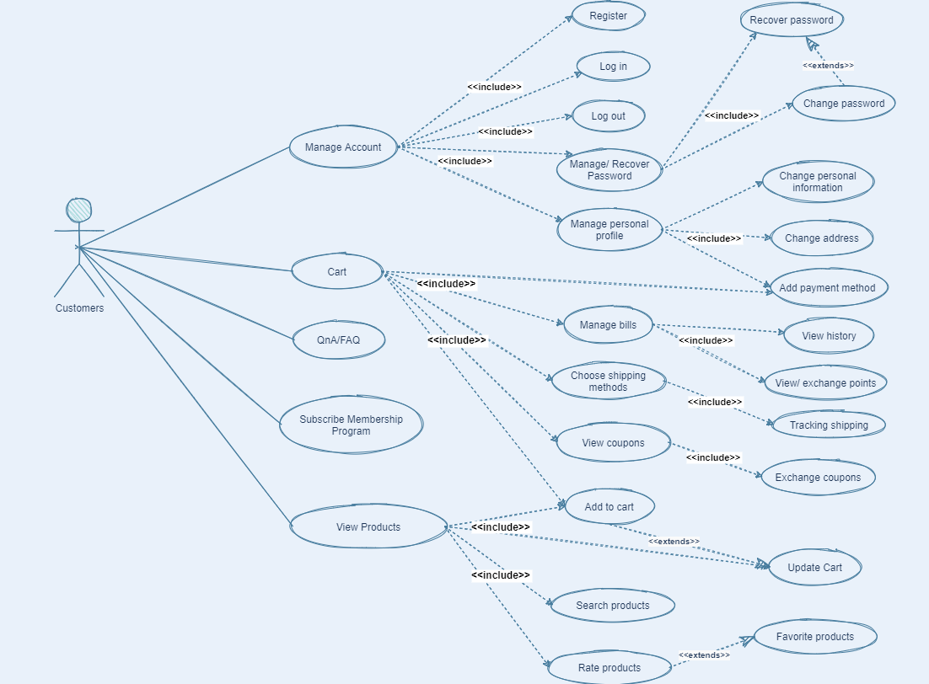

4.2.2 Employee use case

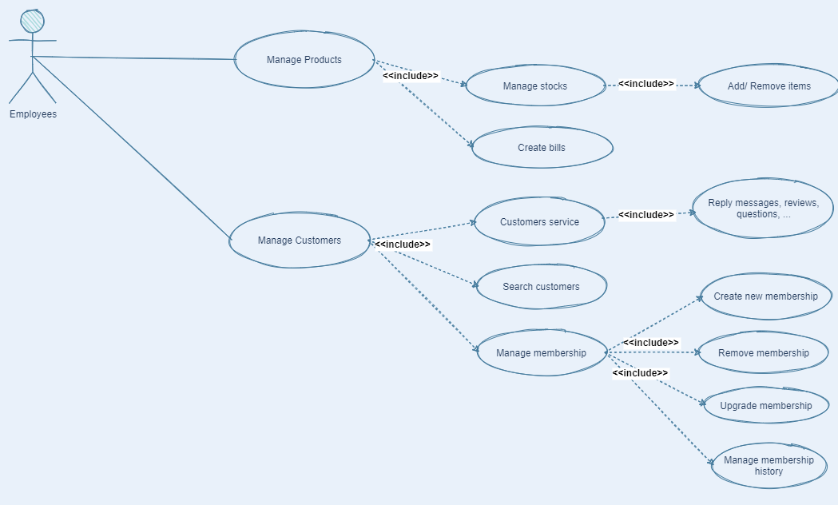

4.2.3 Manager use case

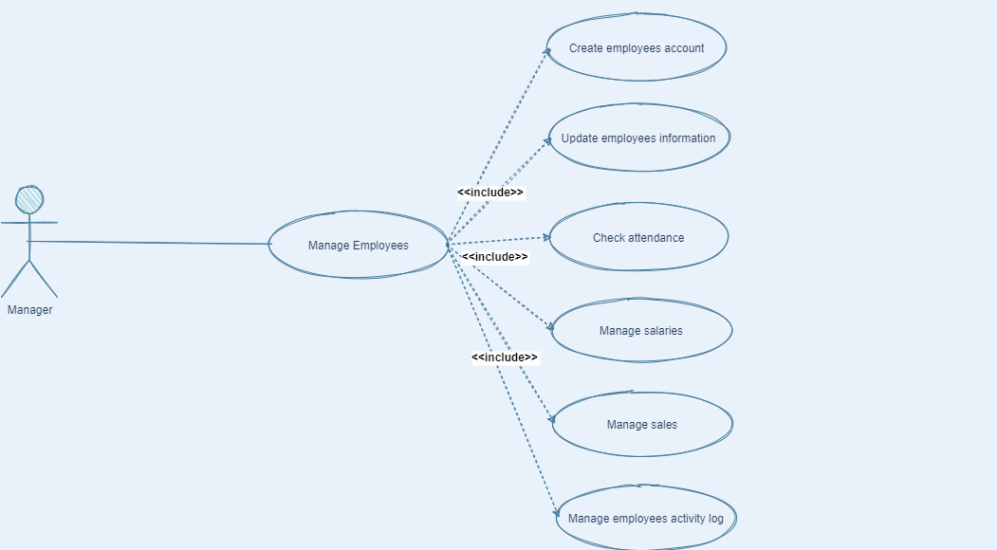

4.3 Use case list

|  |  |  |
| --- | --- | --- |
| N.o | Use case name | Description |
| 1 | Manage account | Manage the username, password, address, payment |
| 2 | Cart | Add item, coupon, manage bill, shiping method |
| 3 | QnA/FAQ | Frequently Asked Questions, question and ask |
| 4 | Subscribe membership | Join special customer program with benefit |
| 5 | View Product | Product in detail: price, date, expire date. |
| 6 | Manage Product | Add, remove, update product |
| 7 | Manage Customers | Add, remove, update customer |
| 8 | Manage Employees | Add, remove, update employee |

4.4 Use case description

4.4.1 Use case Login

|  |  |  |
| --- | --- | --- |
| Use case Login | | |
| Description | User login into their account | |
| Actor | Customer, Employee, Manager | |
| Main Path | Actor action | System Response |
|  | 1. Click on sign in | 1. Display sign in form |
|  | 1. Input username and password | 1. Check valid |
|  |  | 1. Login Success |
|  |  | 1. Return main page |
| Alternate Path | A1. Wrong password or username | |
|  | 5. Input again | |
|  | Return to step 2 | |
| Pre-condition | The user first must has an account | |
| Post-condition | Already Login | |

4.4.2 Use case Sign up

|  |  |  |
| --- | --- | --- |
| Use case Sign up | | |
| Description | User create new account | |
| Actor | Customer, Employee, Manager | |
| Main Path | Actor action | System Response |
|  | 1. Click on sign up | 1. Display sign up form |
|  | 1. Input username and password | 1. Check if username valid |
|  |  | 1. Sign up Success |
|  |  | 1. Return main page |
| Alternate Path | A1. Username is not available or inappropriate | |
|  | 5. Signup failed message | |
|  | Return to step 3 | |
| Pre-condition | Username is not taken | |
| Post-condition | Account created | |

4.4.3 Use case log out

|  |  |  |
| --- | --- | --- |
| Use case Log out | | |
| Description | User log out | |
| Actor | Customer, Employee, Manager | |
| Main Path | Actor action | System Response |
| 1. Click on log out | 1. Display log out form |
|  | 1. Log out success |
| Alternate Path |  | |
| Pre-condition | Already login | |
| Post-condition |  | |

4.4.4 Use case Find item (product)

|  |  |  |
| --- | --- | --- |
| Use case Find item | | |
| Description | Find the item user want | |
| Actor | Customer | |
| Main Path | Actor action | System Response |
|  | 1. Input the key word | 1. Display product list |
| Alternate Path |  | |
| Pre-condition | Already login | |
| Post-condition |  | |

4.4.5 Use case Add Item

|  |  |  |
| --- | --- | --- |
| Use case Add item | | |
| Description | Add the item user want into cart | |
| Actor | Customer | |
| Main Path | Actor action | System Response |
|  | 1. Choose the item | 1. Display product detail |
|  | 1. Click on add item | 1. Item added |
| Alternate Path |  | |
| Pre-condition | Already login | |
| Post-condition | Item added to cart | |

4.4.6 Use case check out

|  |  |  |
| --- | --- | --- |
| Use case check out | | |
| Description | User check out for items in cart | |
| Actor | Customer | |
| Main Path | Actor action | System Response |
| 1. Choose the cart | 1. Display product list in cart |
| 1. User choose payment method | 1. Check out and print bill |
| Alternate Path |  | |
| Pre-condition | Already login | |
| Post-condition | Print bill to user | |

4.4.7 Use case change information

|  |  |  |
| --- | --- | --- |
| Use case Change Information | | |
| Description | User change information of their account | |
| Actor | Customer, Employee, Manager | |
| Main Path | Actor action | System Response |
| 1. Click on change information | 1. Send mail to verify |
| 1. User verified |  |
| 1. Input new info | 1. Update successfully |
|  |  |
| Alternate Path | A1. User name or password invalid | |
| 2. Input again | |
| Return to step 3 | |
| Pre-condition | The user must login first | |
| Post-condition | Information has been changed | |

4.4.8 Use case recovery

|  |  |  |
| --- | --- | --- |
| Use case Recovery | | |
| Description | User reset their password | |
| Actor | Customer, Employee, Manager | |
| Main Path | Actor action | System Response |
| 1. Click on forgot password | 1. Send mail to user |
| 1. User verified | 1. Navigate to reset page |
| 1. User Input new password | 1. Reset successfully |
|  |  |
| Alternate Path | A1. Email cannot reach | |
| Send verify code to phone instead | |
| Return to step 3 | |
| Pre-condition | User forgot their password | |
| Post-condition | Password has been reset | |

4.4.9 Use case add Employee

|  |  |  |
| --- | --- | --- |
| Use case add Employee | | |
| Description | Manager add new employee | |
| Actor | Manager | |
| Main Path | Actor action | System Response |
|  | 1. Click on create new employee | 1. Display form to input |
|  | 1. Input employee information | 1. Check if username valid |
|  |  | 1. Add successfully |
| Alternate Path | A1. Username is not available or inappropriate | |
|  | 5. Add failed message | |
|  | Return to step 3 | |
| Pre-condition | Manager already login | |
| Post-condition | Employee added | |

4.4.10 Use case add Customer

|  |  |  |
| --- | --- | --- |
| Use case add Customer | | |
| Description | Manager or eployee add new customer | |
| Actor | Manager, employee | |
| Main Path | Actor action | System Response |
|  | 1. Click on create new customer | 1. Display form to input |
|  | 1. Input customer information | 4. Check if username valid |
|  |  | 1. Add successfully |
| Alternate Path | A1. Username is not available or inappropriate | |
|  | 5. Add failed message | |
|  | Return to step 3 | |
| Pre-condition | Manager or employee already login | |
| Post-condition | Customer added | |

# V. Analyze

## 5.1. Database Diagram

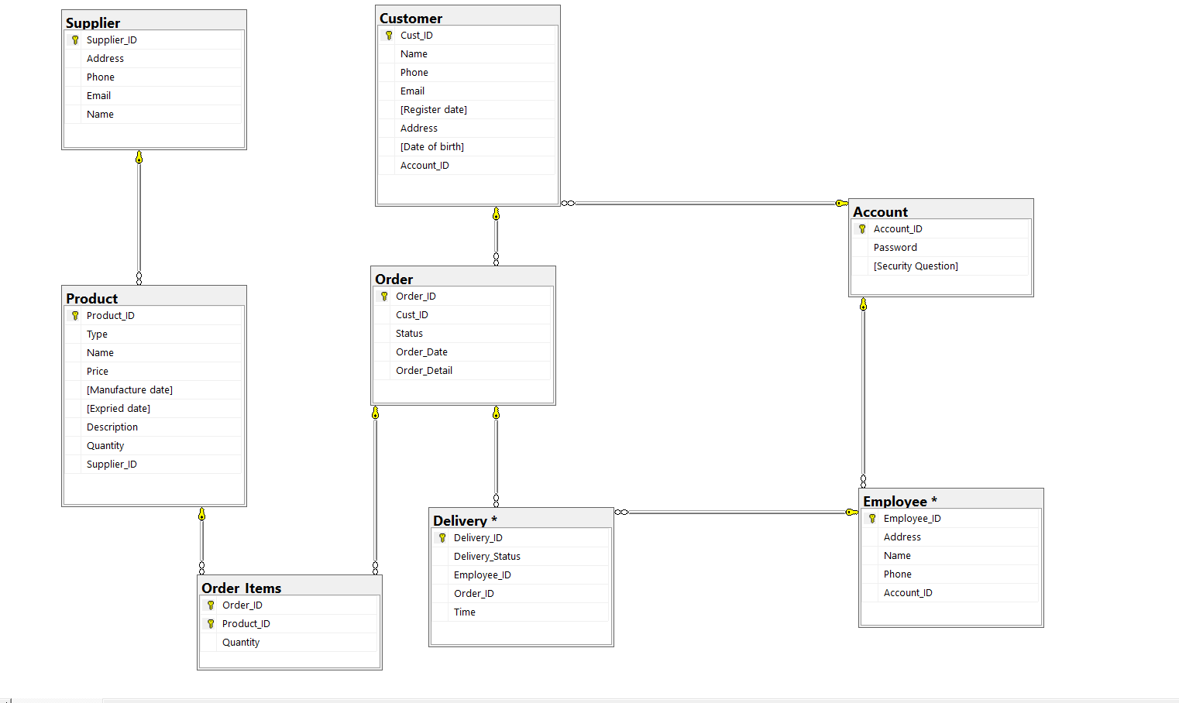

### 5.1.1. List of class object

|  |  |
| --- | --- |
| No | Class name |
| 1 | Account |
| 2 | Employee |
| 3 | Delivery |
| 4 | Order |
| 5 | Customer |
| 6 | Supplier |
| 7 | Product |
| 8 | Order Items |

### 5.1.2. List of Relationship

|  |  |
| --- | --- |
| No | Class name |
| 1 | Account - Employee |
| 2 | Account - Customer |
| 3 | Order - Delivery |
| 4 | Customer - Order |
| 5 | Employee - Delivery |
| 6 | Order - Order Items |
| 7 | Product - Order Items |
| 8 | Supplier - Product |

### 5.1.3. Class Description

#### 5.1.3.1. Account

|  |  |  |  |
| --- | --- | --- | --- |
| Description | Element and Function | Data type | Note |
| Saving account info | Account_ID | Varchar[50] | ID number of account |
| Password | Varchar[50] | Password security of account |
| Security Question | Varchar[100 | Question to confirm account |

#### 5.1.3.2. Employee

|  |  |  |  |
| --- | --- | --- | --- |
| Description | Element and Function | Data type | Note |
| Saving employee info | Employee_ID | Varchar[50] | ID number of Employee |
| Address | Varchar[50] | House Address of Employee |
| Name | Varchar[50] | Name of Address |
| Phone | int | Phone number |
| Account_ID | Varchar[50] | ID of employee’s account |

#### 5.1.3.3. Delivery

|  |  |  |  |
| --- | --- | --- | --- |
| Description | Element and Function | Data type | Note |
| Saving Delivery info | Delivery_ID | Varchar[50] | ID number of Delivery |
| Delivery Status | Varchar[10] | Status of Delivery |
| Employee_ID | Varchar[50] | ID number of Employee |
| Order_ID | Varchar[50] | ID number of Order |
| Time | Date | Time Remaining |

#### 5.1.3.4. Order

|  |  |  |  |
| --- | --- | --- | --- |
| Description | Element and Function | Data type | Note |
| Saving Order info | Order_ID | Varchar[50] | ID number of Delivery |
| Cust_ID | Varchar[50] | ID number of Customer |
| Status | Varchar[10] | Status of Order |
| Order_date | Date | Date of order |
| Order_deatail | Varchar[50] | Detail of order |

#### 5.1.3.5. Customer

|  |  |  |  |
| --- | --- | --- | --- |
| Description | Element and Function | Data type | Note |
| Saving Customer Info | Cust_ID | Varchar[50] | ID number of Customer |
| Name | Varchar[50] | Name of customer |
| Phone | int | Phone number of customer |
| Email | Varchar[50] | Email of customer |
| Register date | Date | Register date |
| Address | Varchar[50] | Address of customer |
| Date of birth | Date | Date of birth of customer |
| Account_ID | Varchar[50] | ID number of Account |

## 5.1.3.6. Order Items

|  |  |  |  |
| --- | --- | --- | --- |
| Description | Element and Function | Data type | Note |
| Saving Order Item info | Order_ID | Varchar[50] | ID number of Delivery |
| Product_ID | Varchar[50] | ID number of Product |
| Quantity | int | Quantity of order item |

5.1.3.7. Product

|  |  |  |  |
| --- | --- | --- | --- |
| Description | Element and Function | Data type | Note |
| Saving Customer Info | Product_ID | Varchar[50] | ID number of Product |
| Type | Varchar[50] | Type of Product |
| Name | Varchar[50] | Name of Product |
| Manufacture date | Date | Manufacture date |
| Expired date | Date | Expired date |
| Description | Varchar[50] | Description of Product |
| Quantity | Date | Quantity of Product |
| Price | real | Price of Product |
| Supplier | Varchar[50] | supplier of Product |

5.1.3.8. Supplier

|  |  |  |  |
| --- | --- | --- | --- |
| Description | Element and Function | Data type | Note |
| Saving Order info | Supplier_ID | Varchar[50] | ID number of Supplier |
| Address | Varchar[50] | Address of Supplier |
| Phone | int | Phone of Supplier |
| Email | Date | Email of Supplier |
| Name | Varchar[50] | Name of Supplier |

5.2. Sequence Diagram

Customer

5.2.1. Manage Account

5.2.1.1.

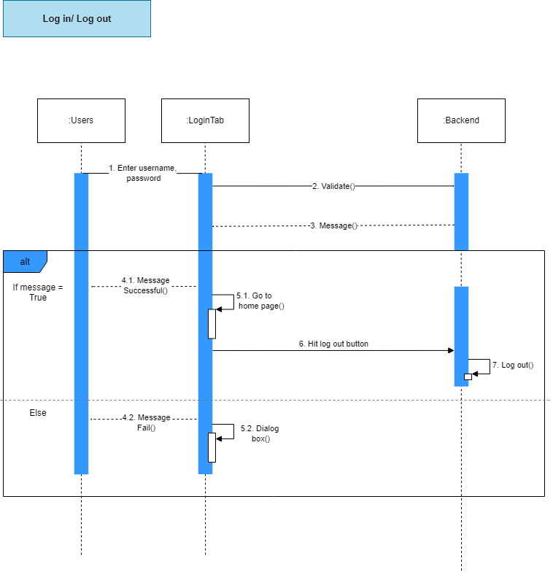

5.2.1.2.

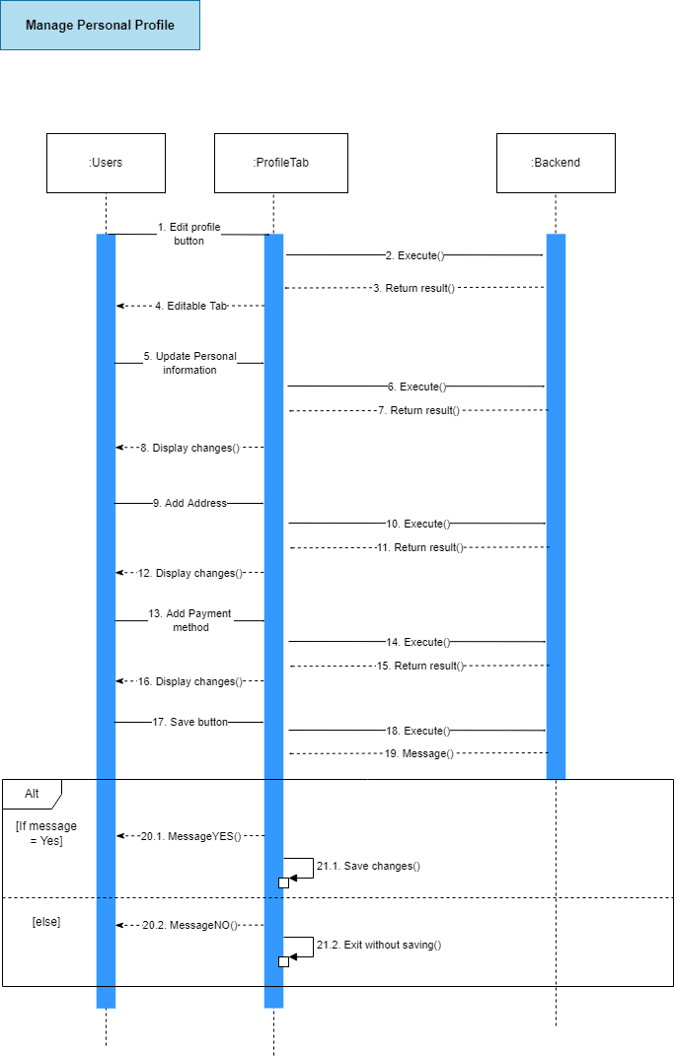

5.2.1.3.

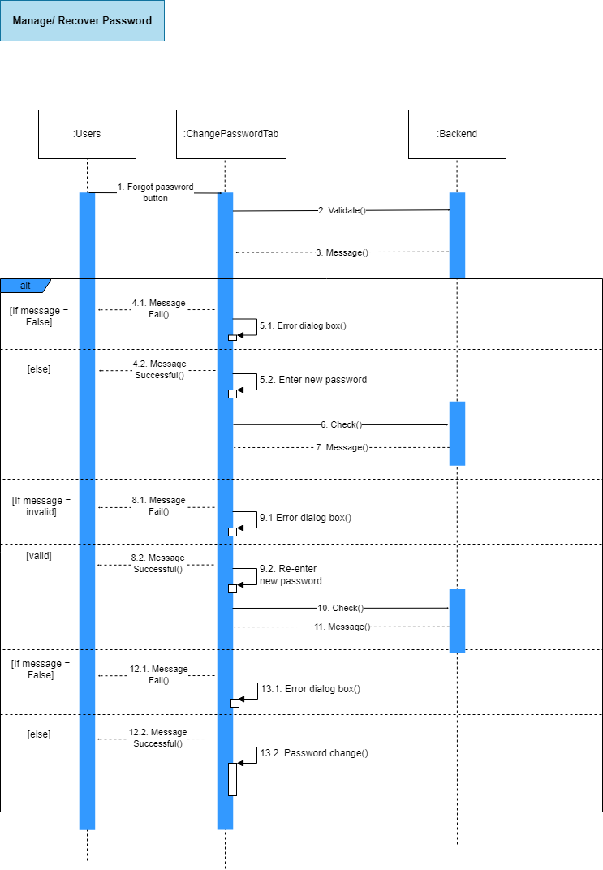

5.2.1.4.

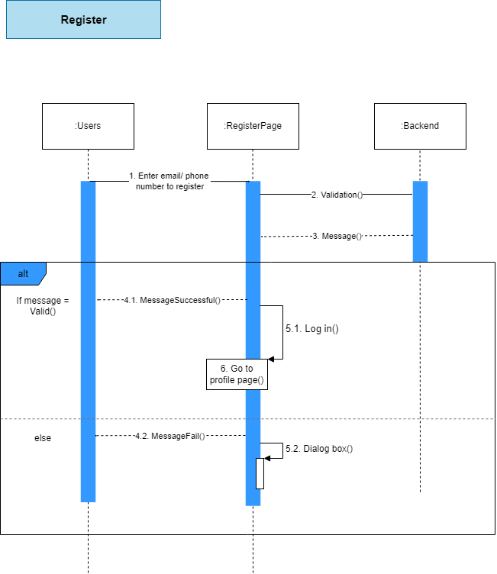

5.2.2. Cart

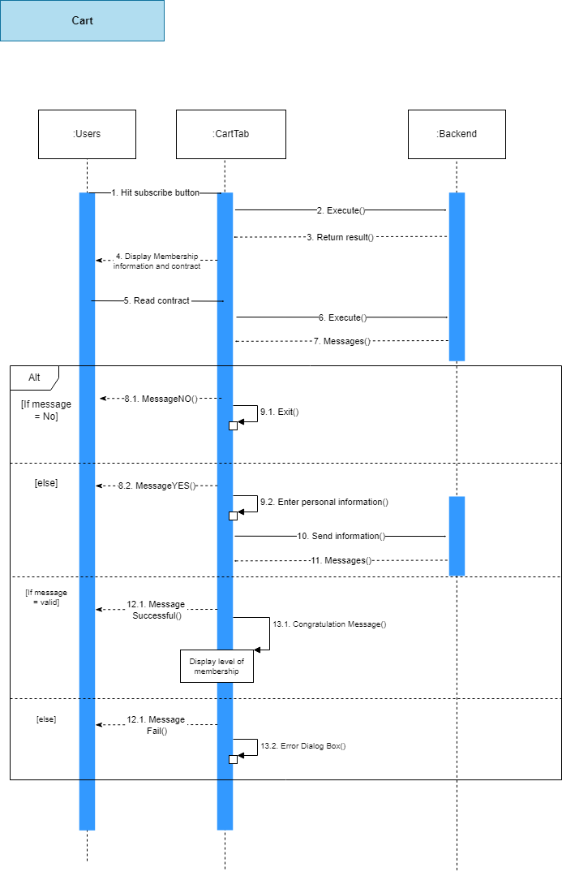

5.2.3. QnA/FAQ

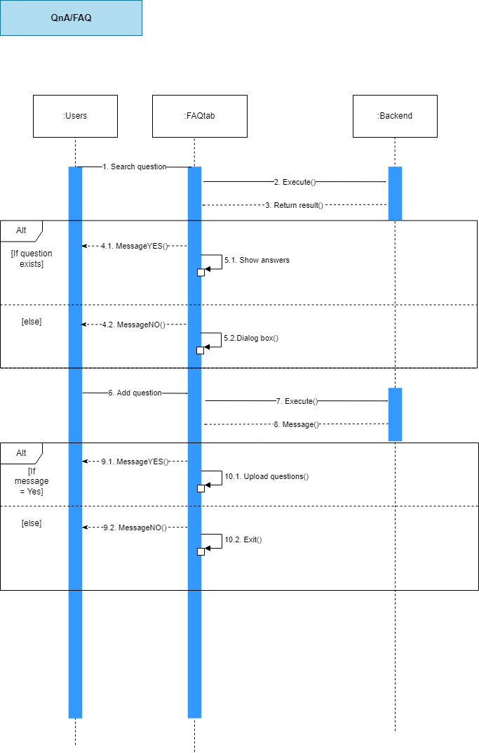

5.2.4. Membership

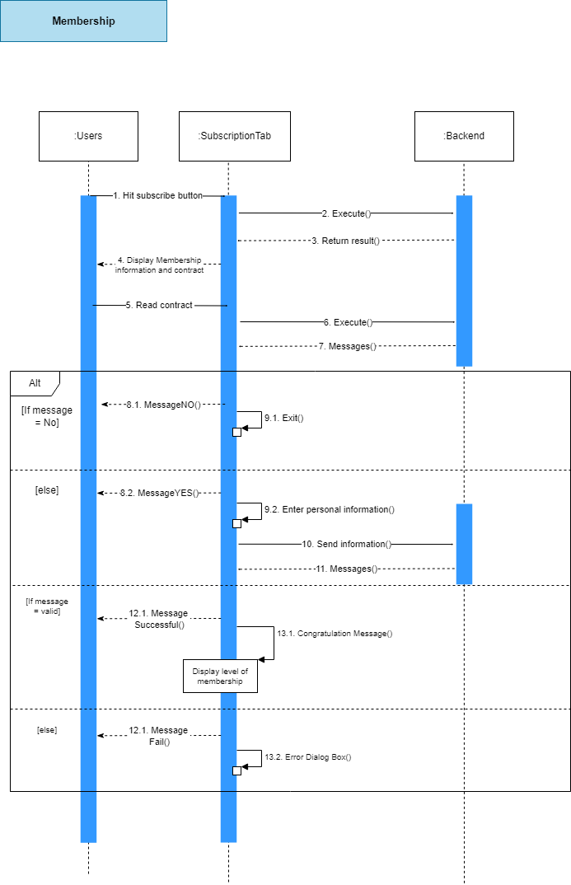

Employees

5.2.5. Manage Product

5.2.5.1

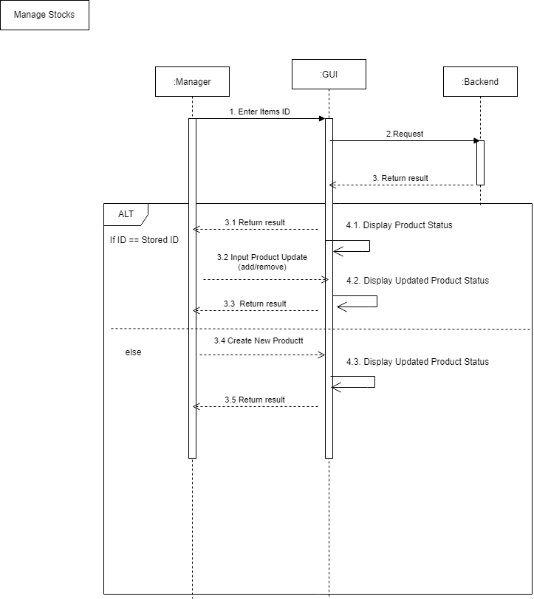

5.2.5.2

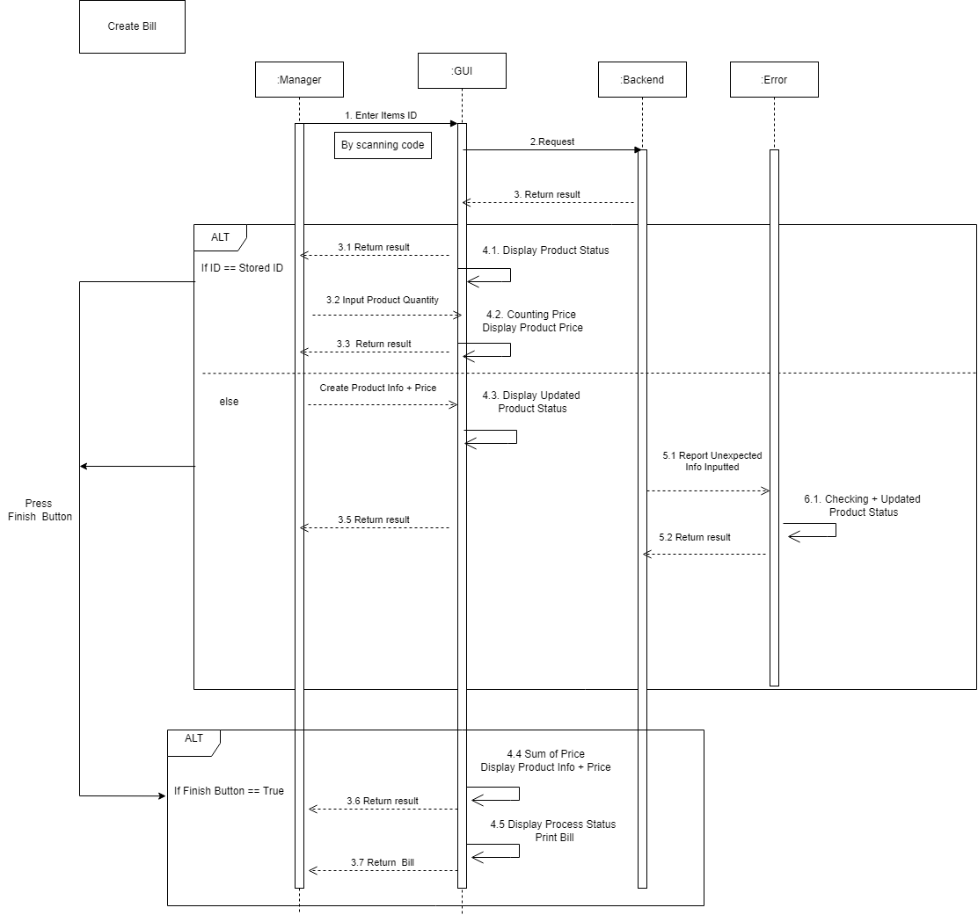5.2.6. Manage Customers

5.2.6.1.

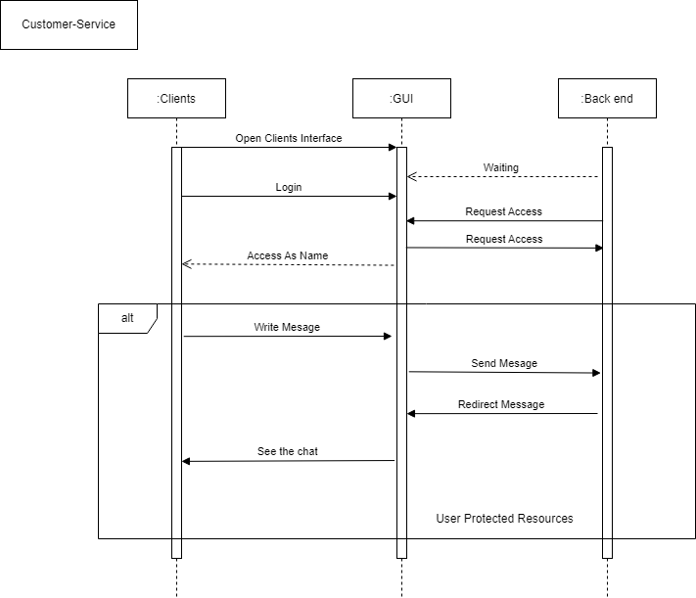5.2.6.2.

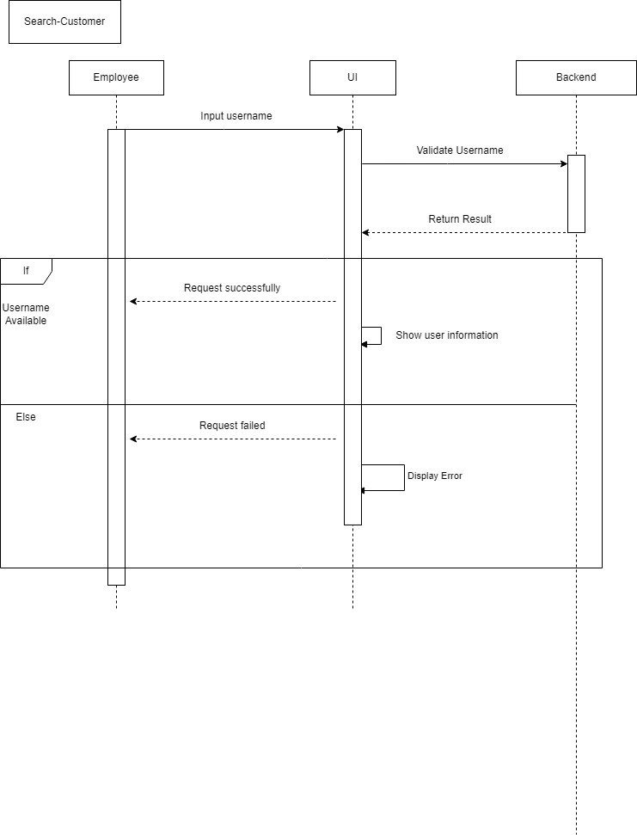

5.2.6.3. Manage Membership

5.2.6.3.1.

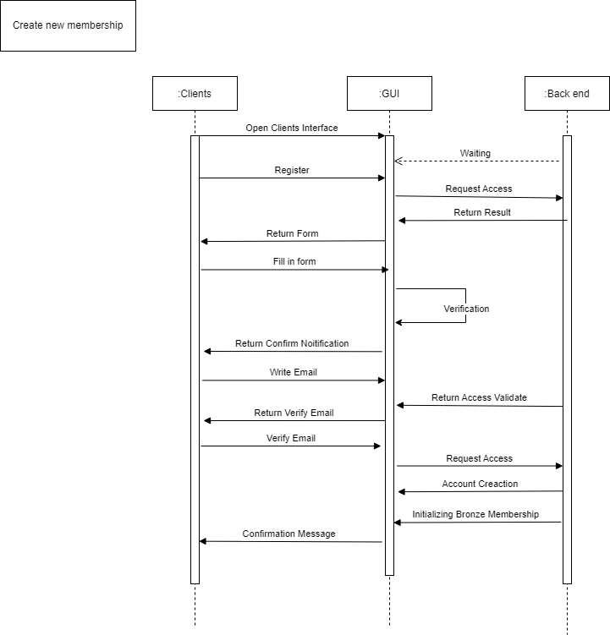5.2.6.3.2.

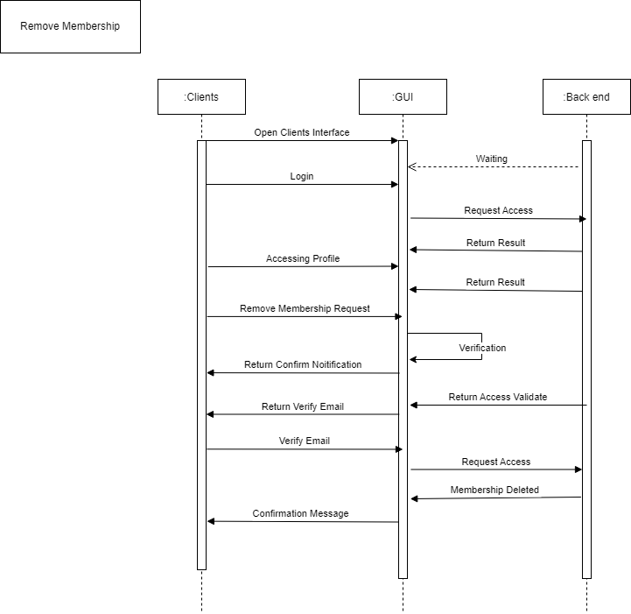

5.2.6.3.3.

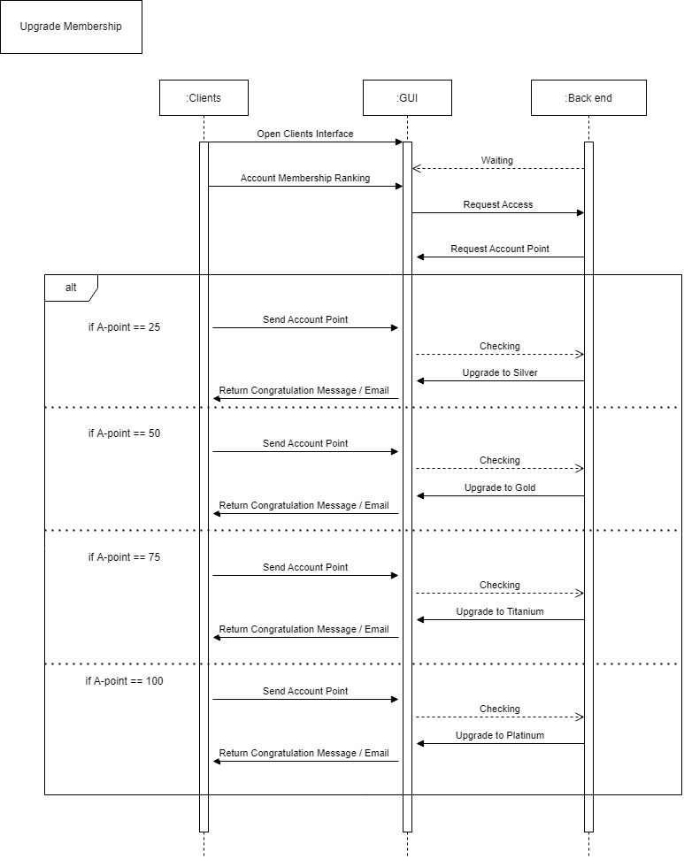5.2.6.3.4.

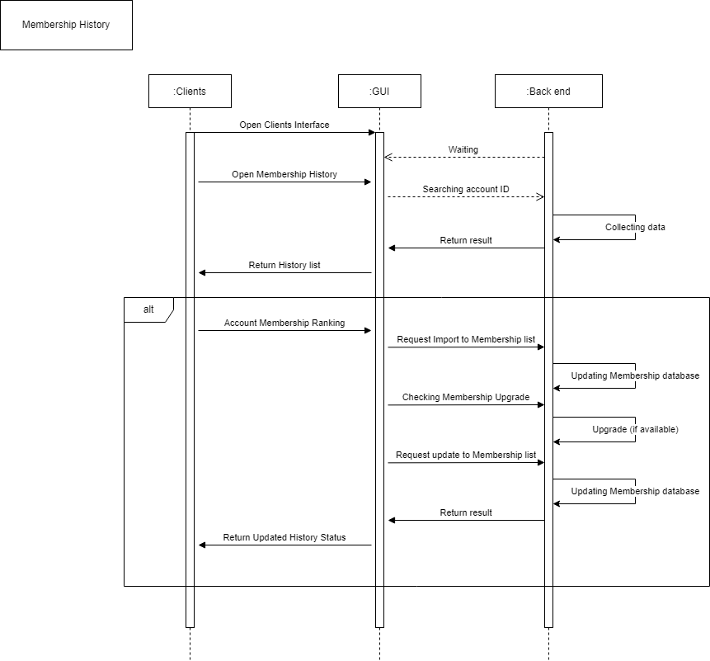Manager

5.2.7. Manage Emplyees

5.2.7.1.

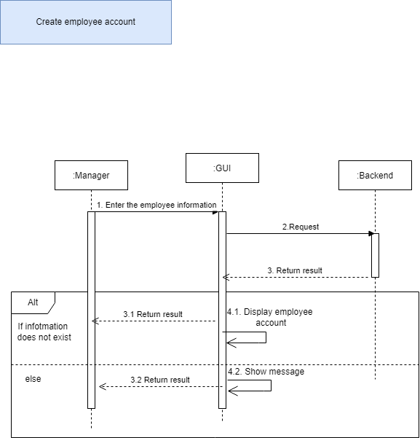5.2.7.2.

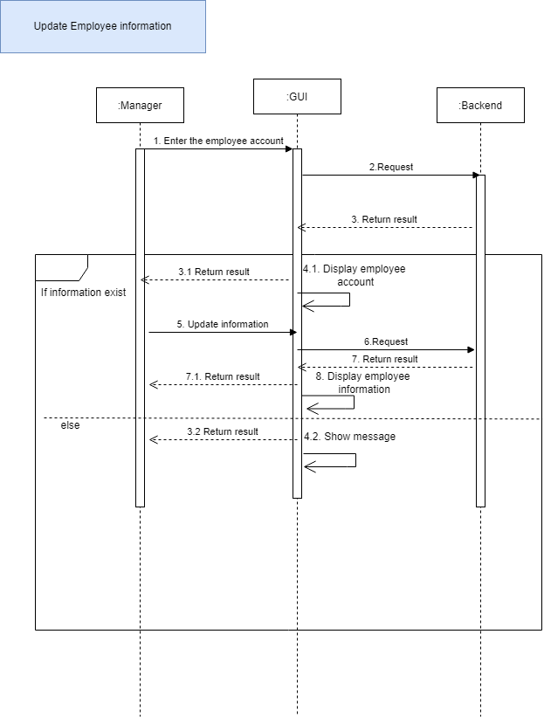5.2.7.3.

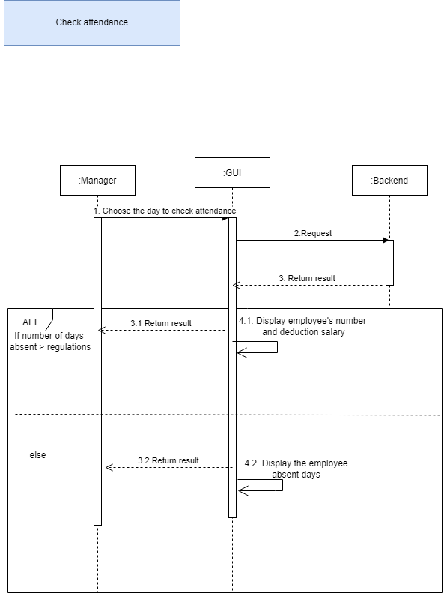

5.2.7.4.

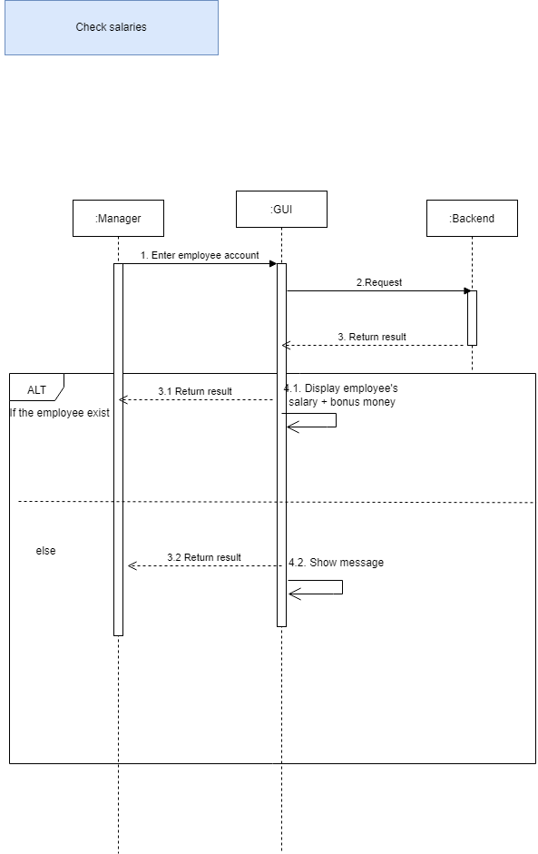

5.2.7.5.

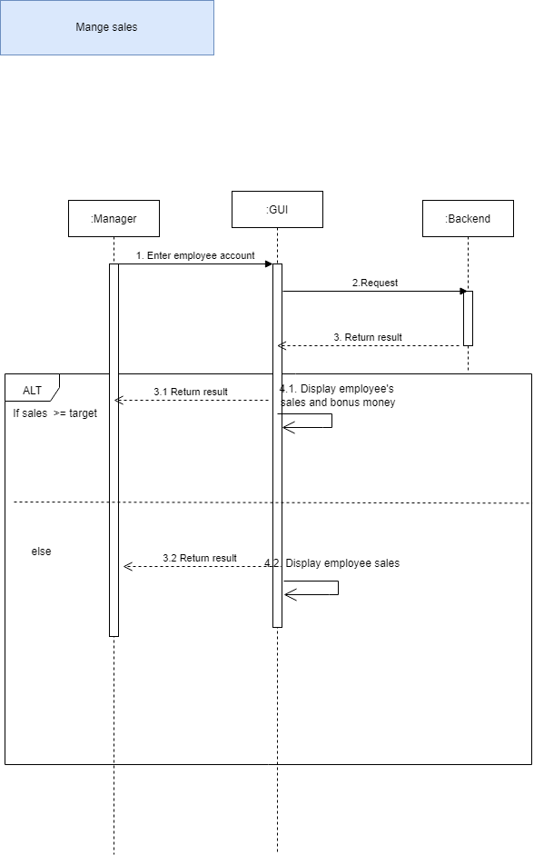

# VI. UI/UX Design

## 6.1. List of pages:

|  |  |  |
| --- | --- | --- |
| STT | Page name | Function |
| 1 | Welcome page |  |
| 2 | About us |  |
| 3 | Contact |  |
| 4 | Log in |  |
| 5 | Sign up |  |
| 6 | Shop main page |  |
| 7 | User profile |  |
| 8 | Account recovery |  |

## 6.2. Details:

### 6.2.1. Welcome Page:

### 6.2.2. About Us:

### 6.2.3. Contact

### 6.2.4. Sign Up

### 6.2.5. Log In:

### 6.2.6. Shop Main Page:

## 6.2.7. Account Recovery:

### 6.2.7.1. Through Email Address:

6.2.8. Profile Page:

# VII. Conclusion:

1. Overview:

In general, the software has basic functions, can basically meet the needs of a small cosmetic store.

2. Advantages:

-Easy to use interface

- Fully meet the basic functions

-Increase store management productivity

3. Cons:

-There is no complete version to put into practice yet

4. Development direction:

-Continue to build the app

-Develop more features to analyze and suggest products suitable for customer's skin type